Portfolio Project #01
Global Firepower 2025 Analysis – A Strategic Insight

Business Questions and Insights

Q1: Does higher defense spending always lead to stronger military power?
Top 30 countries by defense expenditure
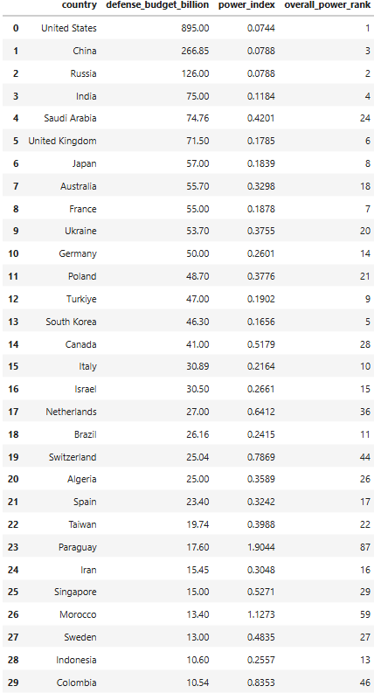
While extremely high defense spending enables top-tier military capability, increased budgets do not guarantee proportional improvements in power. After a threshold, strategic allocation, institutional efficiency, and technological integration play a greater role than raw expenditure.

Insight
High defense spending does not automatically translate into higher military power.
- Some countries with very large budgets ranked lower than expected
- Several countries achieved strong rankings with moderate spending
Business Meaning
How your defense budget is allocated matters more than how much is spent

Q2: Are countries efficient in converting budget into power?
Top 30 countries by budget efficiency
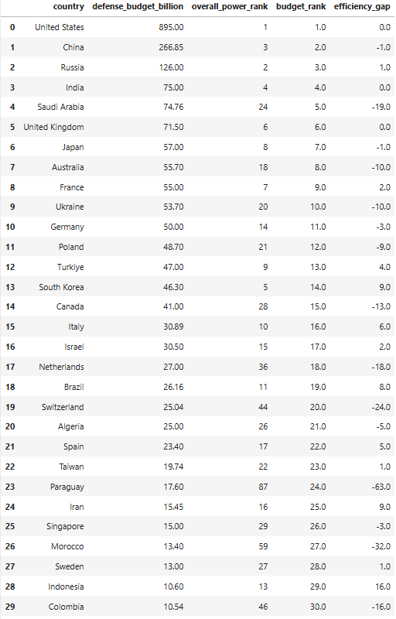

Defense spending efficiency varies significantly across countries. Several mid-sized nations outperform their budget ranks through strategic allocation and institutional effectiveness, while some high-spending countries underperform due to structural and operational inefficiencies. Top military powers combine scale with disciplined spending.

Insight:
Military efficiency varies significantly across countries
- Some countries outperformed their budget rank
- Others underperformed despite high spending

Business Meaning
Strategic planning and institutional effectiveness drive military outcomes.

Q3: Manpower vs Technology — which matters more?
Top 15 countries by weapons technology
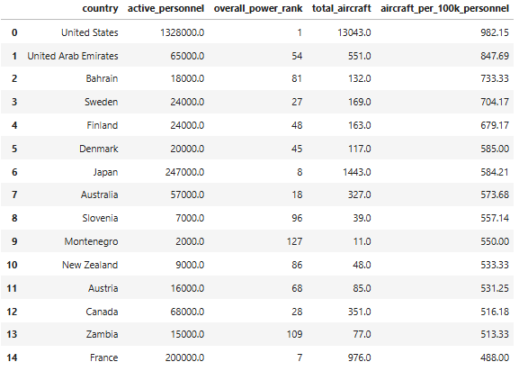

Countries with limited manpower tend to adopt technology-intensive military strategies, using advanced airpower to compensate for smaller forces. While major powers also maintain high technology density, manpower-heavy countries generally show lower technology intensity.
This indicates that modern military effectiveness increasingly depends on technological leverage rather than sheer troop size.
Insight:
Technology acts as a force multiplier in modern warfare.
- Smaller militaries with high aircraft-per-personnel ratios ranked strongly
- Large manpower-heavy forces underperformed without matching technology

Business Meaning
Quality increasingly outweighs quantity in military capability.

Q4. Logistics vs Weapons — what matters more?
Top 15 countries with strong logistics
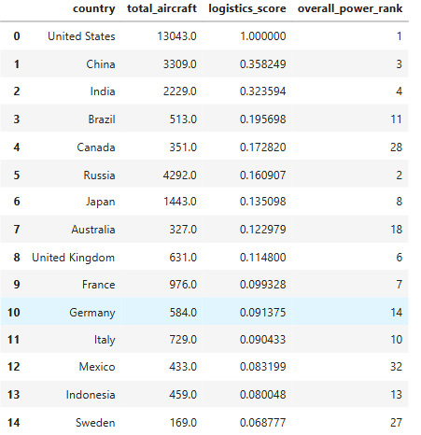

While weapons strength is essential for combat capability, logistics infrastructure is the key enabler of sustained military power. Countries with strong logistics consistently achieve high rankings even with moderate weapon counts, whereas weapons-heavy countries with weak logistics struggle to project power effectively.

Insight
Logistics is a critical enabler of military effectiveness.
- Top-ranked countries had strong logistics capacity
- Weapons-heavy countries with weak logistics ranked lower
Business Meaning
Operational sustainability matters as much as combat power
Q5: Geography & Resources — do they determine power?
Top 15 countries with strong geography
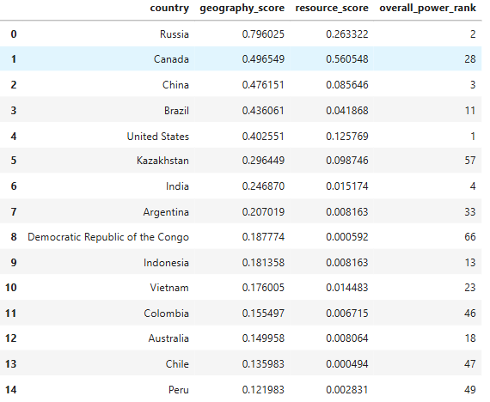

Geography is a foundational enabler of military power that sets upper limits on strategic potential. However, only countries that combine geographic advantages with strong logistics, technology, and industrial capacity are able to convert this potential into sustained dominance which is evident from the rankings above.
Top 15 countries with strong resources
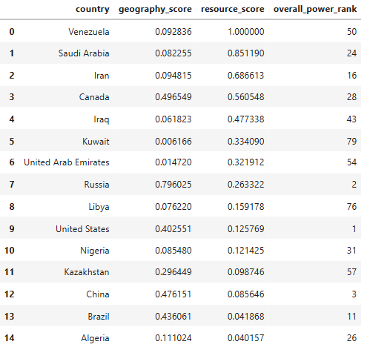
Natural resource abundance supports long-term sustainability and defense funding, but it does not translate directly into military power. Resource-rich countries frequently underperform militarily due to weak industrial integration, limited technological development, and governance constraints. The strongest militaries rely more on industrial capacity and innovation than on raw resource ownership.

Insight:
Geography and natural resources create potential, not dominance.
- Resource-rich countries often ranked mid or low
- Large geographic countries underperformed without capability investment
- Top powers had moderate resources but strong integration
Business Meaning
Structural advantages must be converted into operational capability.

Project Summary:
This project analyses global military power using a multi-dimensional, data-driven approach. By combining financial, manpower, technological, logistical, geographic, and natural resource indicators, the study evaluates how different strategic factors contribute to overall military effectiveness.
Key findings show that extremely high defense spending enables top-tier power but exhibits diminishing returns beyond a threshold. Budget efficiency varies widely, with several mid-sized nations outperforming their spending levels. Technology intensity increasingly outweighs raw manpower, while logistics infrastructure emerges as the strongest enabler of sustained military capability. Geographic scale and natural resources provide structural advantages but do not independently guarantee dominance without strong institutional and industrial integration.
Overall, the analysis demonstrates that modern military strength is driven by balanced investment, efficient resource utilization, and strong operational infrastructure rather than reliance on any single factor.

